# Jetson Orin Setup Manual

Table of Contents

Jetson Orin Setup Manual 1

1. Upgrade Jetpack using SDK Manager 1

1.1. Prepare a host 1

1.2. Download SDK Manager 2

1.3. Connect Jetson Orin to host and put the board into Recovery Mode 2

1.3.1. Connect Jetson Orin to host 2

1.3.2. Put Jetson Orin into Recovery Mode 3

1.3.3. (For WSL2 only) Connect USB devices to WSL2 3

1.3.4. Confirm if host is successfully connected to Jetson Orin in Recovery Mode 3

1.4. Upgrade using SDK Manager 3

1.4.1. Flash OS 4

1.4.2. Login into Jetson Orin and Initialize the OS. Connect Jetson to a Wi-Fi / Ethernet. 5

1.4.3. Install Jetson SDK Components through Ethernet using SDK Manager 5

1.5. Check if Jetpack OS is successfully installed 6

1.6. Check if Jetpack SDK Components are successfully installed 6

2. Configurate Additional SSD 7

2.1. Formula the SSD 7

2.2. Change Mount Point 8

2.3. Start the SSD 9

2.4. Verify SSD Performance 9

2.5. Access SSD 11

3. Install RT-Kernel 11

3.1. Verify if RT-Kernel is installed 11

**All information is referenced to** [**Jetpack6.2**](https://developer.nvidia.com/embedded/jetpack-sdk-62) **and Jetson Orin with SDK Manager v2.2.0.**

Author: Ruby Lam

Last Edit Date: 2/4/2025

## Upgrade Jetpack using SDK Manager

### Prepare a host

SDK Manager need to be installed on a separate x86-64(Amd64) host and flash to the Jetson device with a USB Type-C cable.

For Jetpack6.2, Ubuntu 20.04 / 22.04 / 24.04 is supported.

See <https://developer.nvidia.com/sdk-manager#host_os_comp_matrix>

### Download SDK Manager

* Download **Ubuntu .deb** from [here](https://developer.nvidia.com/sdk-manager).
* Install the SDK Manager with command

“sudo dpkg -i sdkmanager_2.2.0-12028_amd64.deb”

### Connect Jetson Orin to host and put the board into Recovery Mode

#### Connect Jetson Orin to host

* Connect a USB Type-C cable to Type C Port(10) of Orin and host.
* Plug in power cable into Type C Port (4) of Orin.

#### Put Jetson Orin into Recovery Mode

* Press and hold down the Force Recovery button ( 2 ).
* Press and hold down the Reset button ( 3 ).
* Hold for 1 second.
* Release the Reset button ( 3 ) and then then Force Recovery button ( 2 ).

#### (For WSL2 only) Connect USB devices to WSL2

In Window PowerShell, type the following

#### Confirm if host is successfully connected to Jetson Orin in Recovery Mode

In Ubuntu host, type the following

### Upgrade using SDK Manager

In host terminal, type “sdkmanager” to open the SDK Manager. Login in and follow steps as shown below.

#### Flash OS

**3**

**1**

**2**

**2**

**1**

**2**

**1**

#### Login into Jetson Orin and Initialize the OS. Connect Jetson to a Wi-Fi / Ethernet.

* Connect Jetson Orin with a monitor, mouse and keyboard. Login in and initialize the Ubuntu system.
* Connect Jetson Orin to the internet.

#### Install Jetson SDK Components through Ethernet using SDK Manager

* Default IP for installed system is 192.168.55.1

**1**

**2**

### Check if Jetpack OS is successfully installed

For Jetpakc6.2, **L4T36.4.3** is installed as shown below.

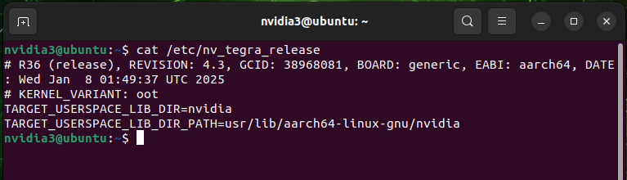

### Check if Jetpack SDK Components are successfully installed

For Jetpack6.2, **Cuda 12.6** is installed as shown.

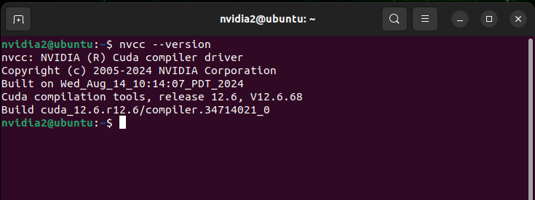

## Configurate Additional SSD

Open Disks from Ubuntu Applications and follow instructions below.

### Formula the SSD

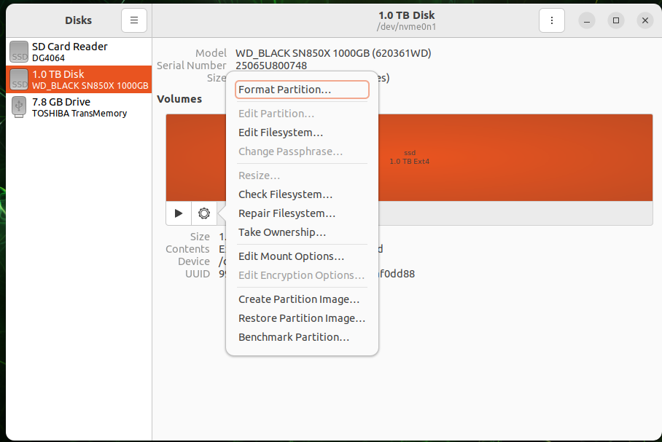

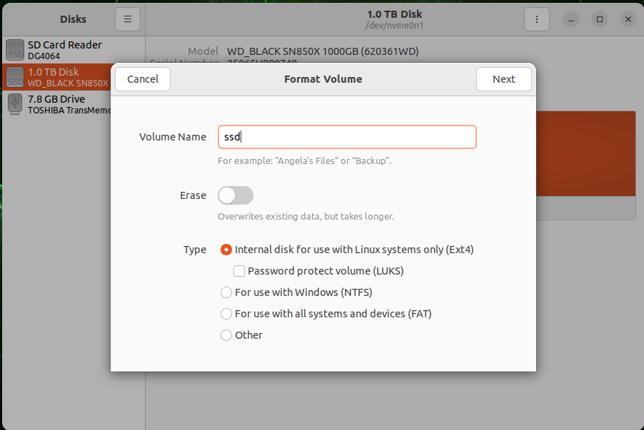

### Change Mount Point

### Start the SSD

### Verify SSD Performance

### Access SSD

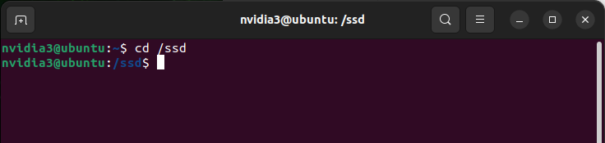

## Install RT-Kernel

Install RT Kernel using OTA update from [here](https://docs.nvidia.com/jetson/archives/r36.4/DeveloperGuide/SD/Kernel/KernelCustomization.html#real-time-kernel-using-ota-update). Be aware of the release version (i.e. r36.4) in the link.

### Verify if RT-Kernel is installed

* Before installation

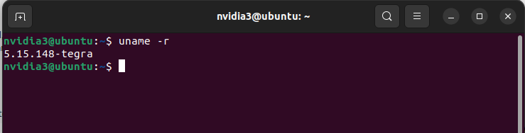

* After installation

